Neon Retro Rave Sprout Bundle | Festival Hair Clip Set
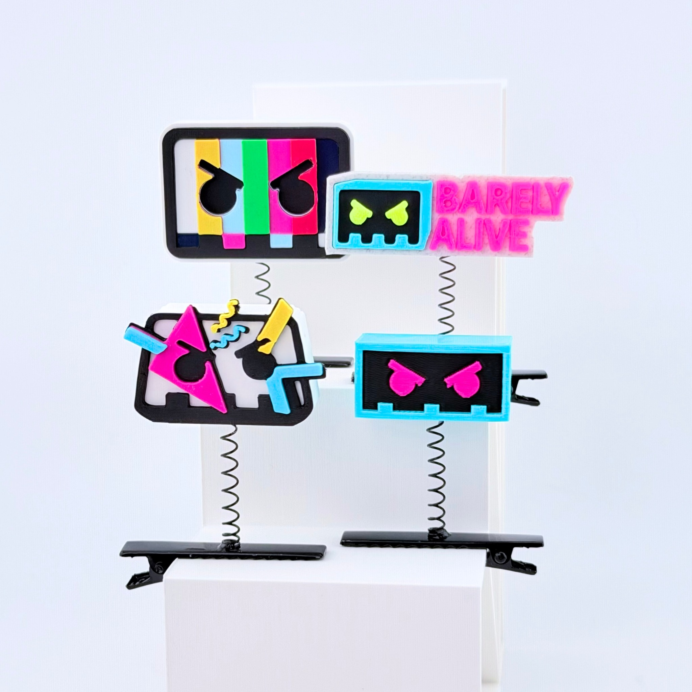
3D-printed PLA spring hair clips with metal alligator clips, sold as an assorted bundle. Photo shows four design examples from the set.

Keyword Strategy
Primary: rave sprout bundle
Secondary: rave hair clip set, festival hair accessories, neon rave accessories, EDM festival accessories, rave trinkets
Keywords are relevance-based recommendations; search volumes were not independently verified.

Shopify
Product title: Neon Retro Rave Sprout Bundle | Festival Hair Clip Set
Bring a full lineup of neon energy to your next rave with this arcade-inspired Rave Sprout bundle! Each pack mixes bold colors, pixel-inspired graphics, and playful geometric designs, so your set comes with a variety of looks. Every Rave Sprout sits on a flexible spring attached to a metal alligator hair clip, making it easy to accessorize your hair, hat, or festival outfit, and the built-in Sprocket spring pocket helps keep each charm attached to its spring. Whether you're outfitting your rave crew, stocking up for a weekend of trading, or looking for a fun festival gift, this bundle is ready to join the lineup.
- Assorted Neon Arcade Designs: A mix of pixel-inspired graphics and bold geometric details in every pack.
- Lightweight PLA: 3D-printed accessories for festival styling.
- Sprocket Feature: Built-in spring pocket helps secure each charm.
- Individually Packaged: Each Rave Sprout in the bundle comes packaged separately.

SEO page title: Neon Retro Rave Sprout Bundle | Festival Hair Clips
Meta description: Shop a neon retro arcade rave sprout bundle. Assorted 3D-printed festival hair clips with colorful pixel-inspired designs in 11, 22 or 33 packs.

Etsy
Product title: Neon Arcade Rave Sprout Bundle, 3D Printed Festival Hair Clip Set, Assorted EDM Hat Clips, Rave Trinkets & Gifts
Level up your whole crew's festival accessories with this colorful, arcade-inspired Rave Sprout bundle! Each pack mixes vibrant neon colors, retro pixel-style graphics, and bold geometric details, so you get a variety of 3D-printed hair clips that bring playful energy to any rave outfit. Each lightweight PLA charm sits on a spring attached to a metal alligator clip. Perfect for sharing with friends, trading at your next show, or gifting to the EDM lover in your life. Available in 11, 22 or 33 packs with bonus sprouts included.
- Assorted Arcade Designs: A mix of bright neon colors and pixel-inspired designs.
- Lightweight 3D Prints: Made from PLA plastic.
- Secure Spring Attachment: Built-in Sprocket pocket helps hold each charm in place.
- Individually Packaged: Each sprout in the bundle is packaged separately.

13 Etsy tags: rave sprout bundle, festival hair clips, edm accessories, sprout clips, neon hair clips, 3d printed clips, pixel art accessory, plur gifts, hair clip set, kandi, hat clips, bulk hair clips, arcade hair clips
Recommended category: Accessories > Hair Accessories > Barrettes & Clips

TikTok Shop
Product title: Neon Arcade Rave Sprout Hair Clip Bundle, 3D Printed Festival Hair Accessories Set
Add a pop of neon to your whole crew! This arcade-inspired Rave Sprout bundle mixes colorful pixel-style designs, each mounted on a flexible spring with a metal alligator clip. Lightweight, playful, and easy to style with festival outfits, hats, or hairstyles.
- Assorted Neon Arcade Designs: A mix of bright colors and pixel-inspired details in every pack.
- Lightweight PLA: 3D-printed decorative charms.
- Metal Hair Clips: Spring alligator clips for easy attachment.
- Built-in Sprocket: Spring pocket helps secure each charm.
- Bundle Packs: 11, 22 or 33 assorted sprouts with bonus sprouts included, each packaged separately.

Recommended category: Hair Accessories > Hair Clips (confirm in Seller Center)

